Azure Cosmos Database:

Consistency levels:
Consistency levels in Azure Cosmos DB define the balance between data accuracy, availability, latency, and throughput in a globally distributed database.

Azure Cosmos DB consistency defines how data is committed to different replicas and data consistency for reads across replicas.
Strong Consistency:
This level provides the highest level of data accuracy, guaranteeing that every read returns the most recent committed version of an item.

Session Consistency:
This is the default consistency level for Azure Cosmos DB. It guarantees that within a single client session, all read and write operations will be consistent.

Eventual Consistency:
This is the weakest consistency level, offering the highest availability and lowest latency.

Default Column added in Database:
_rid, _self,_etag,_attachments,_ts
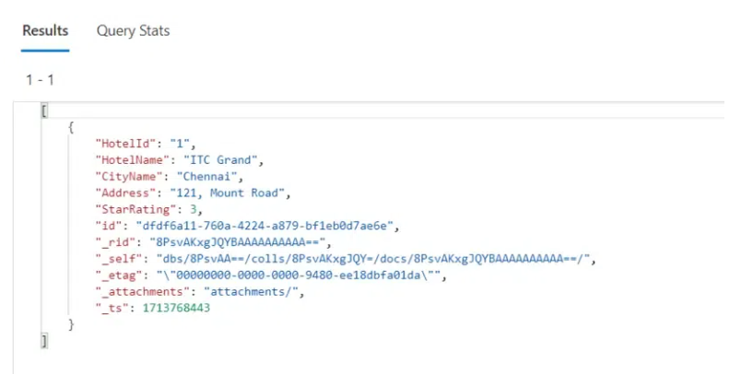

Partition Key
The partition key is a property defined by the user in a cosmos db container associated to each document stored. The partition key is composed of the partition key path and partition key value. As an example "/userid" is the path and a value "johndoe" related to the key 'userid' is the partition key value.

Logical Partitions
The data stored within a container are divided into logical groups based on the partition key values. Logical partitions enable to distribute data across multiple servers. All documents with same partition key value are stored in the same logical partitions.

Physical Partitions
The physical partitions are the underlying storage in cosmos db which holds one or more logical partitions for optimal storage and performance. The physical partition is fully managed by the Azure cloud services and not controlled by users.

Throughput
Throughput refers to the amount of resources allocated for handling operations like read, write, delete or query in a database, measured in Request Units per second or RUs. Throughput in azure cosmos db can be provisioned on a per-container basis or shared within multiple containers of a database.

What is Cosmos DB’s maximum size?
The maximum document size for Cosmos Db is 2 MB, while the largest logical partition size is 20 GB.
What is a Partition Key?
A logical key that distributes data across physical partitions for horizontal scaling; choosing an effective partition key is crucial for performance.
Logical vs. Physical Partitions?
Logical partitions hold your data, while physical partitions are the underlying units of storage and throughput managed by Cosmos DB; data is distributed into logical partitions, which map to physical ones.
Indexing?
Cosmos DB automatically indexes data by default, but you can customize indexing policies (e.g., include/exclude paths) to optimize performance for specific queries.

Link: https://www.geeksforgeeks.org/devops/partition-key-in-azure-cosmos-db/

Cosmos DB Query:
https://www.sqlshack.com/querying-json-documents-in-azure-cosmos-db-using-the-sql-api/

{
"employeeId": 101,
"firstName": "Brian",
"lastName": "Woods",
"Age": 33,
"Gender": "Male",
"Pets": [
"Fish",
"Dog",
"Cat"
],
"phoneNumbers": [
{
"type": "work",
"number": "5563459874"
},
{
"type": "home",
"number": "1453459874"
}
],
"Address": {
"streetAddress": "300",
"city": "Jersey City",
"state": "New Jersey",
"postalCode": "07028"
}
}

{
"employeeId": 102,
"firstName": "Maria",
"lastName": "Torres",
"Age": 37,
"Gender": "Female",
"Pets": [
"Dog",
"Cat"
],
"phoneNumbers": [
{
"type": "work",
"number": "8954598740"
}
],
"Address": {
"streetAddress": "568",
"city": "California",
"state": "San Francisco"
}
}

Query 1:
SELECT p.employeeId, p.firstName, p.Gender,
p.phoneNumbers[0].number
FROM Personnel p
WHERE p.phoneNumbers[0].type = 'Travel'

Query 1:
SELECT p.employeeId, ph.type AS PhoneTypeAvailable
FROM Personnel p
JOIN ph IN p.phoneNumbers

Query 3:
SELECT * FROM c
WHERE ARRAY_CONTAINS (c. address, "best seller")

